Tatton Wildlife Newsletter – Autumn
The colours of autumn are a magnificent spectacle within the parkland landscape. As the days gets shorter and colder, we can witness the changes as nature prepares for the harsher months ahead. It is a great time to get out in the park and enjoy the treasures it has to offer.
Deer
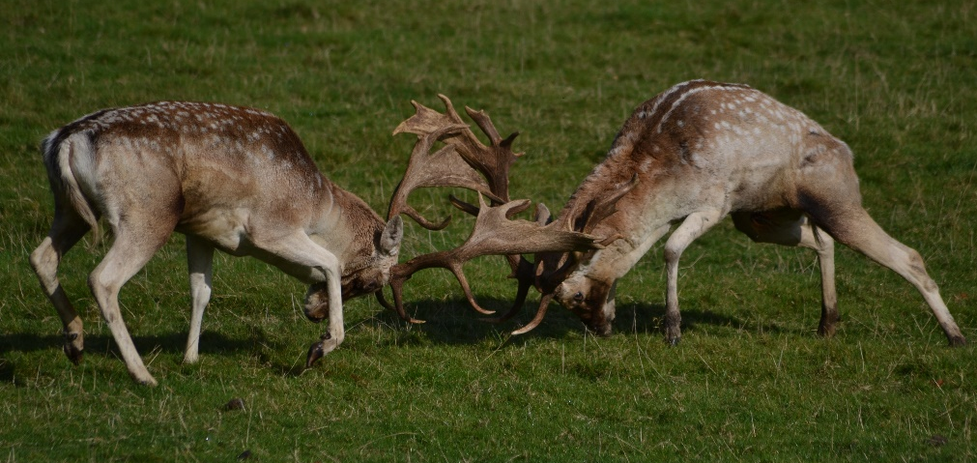
Autumn is the time of the deer rut, and some fascinating aspects of their behaviour can be observed. This begins with the males wallowing in muddy scrapes that they may have previously urinated in. Coating themselves in mud to look (and smell) intimidating, they may also adorn their antlers with grass as they thrash them on the ground. They become vocal to warn away rival suitors or attract a female. The red deer’s bellow can be heard for a considerable distance while the fallow deer have a repetitive rasping, belching call. You may also see the fallow bucks parallel walking where two males walk alongside each other seemingly weighing each other up!
The last resort is the actual clashing of antlers. The antlers lock together, and a battle of strength ensues with the dominant male overpowering the other. Luckily injuries are not common.
Red deer group together as many females as they can in a harem while the fallow deer hold a territory known as a “stand” and call the females to them. The females are in season for a very short time, and it is important that they mate as early as possible to avoid mating in a second cycle later, which then leads to late born young the following year and these are the ones that tend to struggle in the winter. Therefore, it is of utmost importance to leave them undisturbed to allow them to behave naturally at this time of year.

Birds
Our summer birds now leave and having reared their young here, they head for sunnier climes. Migrants begin to arrive from the north to spend our relatively mild winter with us. Various species of wildfowl gather on the meres and winter thrushes arrive, feasting on berries.
It is pleasing to report two pairs of barn owls nesting in the park this year. Two species that are becoming scarcer both here and nationally were seen too: a little owl and a spotted flycatcher, both of which are suspected of nesting also. Other interesting sightings included two green sandpipers and a hobby.
Woodland
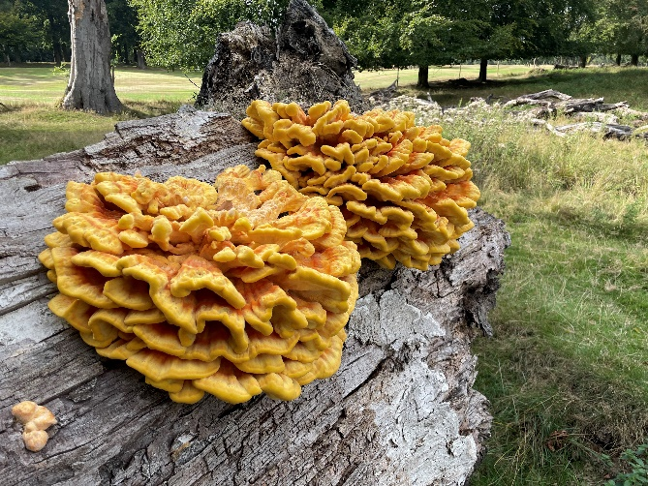
The Autumn woodlands are full of both colour and life. Leaves are the powerhouses of trees, providing its food and a mature oak tree can also provide enough oxygen for 10 people for a year. As the leaves start to die in autumn, the tree takes back reusable proteins and green chlorophyll, revealing the yellow and red pigments produced by sugars remaining in the leaf.
With the loss of leaves, other things that live in the woodlands become more noticeable – fungi, mosses, and lichens. Fungi can appear on living trees (as parasites), but they are also important in breaking down dead and decaying matter (saprophytic). Generally, they need damp conditions to produce their fruit bodies, but most are still very selective in the conditions they need for survival and are usually host specific. Oak and birch trees are good places to look for fungi. The classic red and white spotted toadstool (Fly Agaric) is often spotted near a birch. Beefsteak fungus has a dark red, sticky upper surface and is a bracket found growing on Oak trees. Bracket fungi gain height to spread their spores further by attaching to tree trunks. Please be aware that some fungi species are poisonous so look, but don’t taste or touch!

Compiled by Tatton’s Ranger Team

